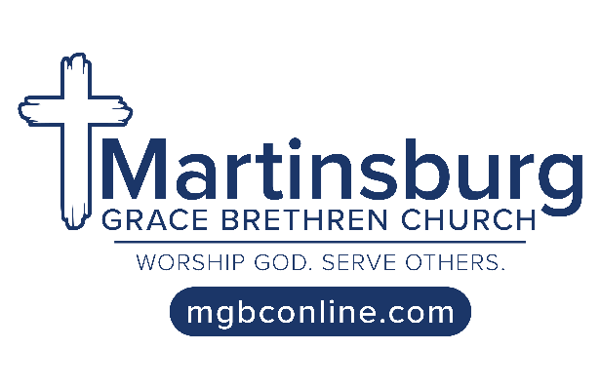
Prayer Requests

Wednesday, June 16, 2021

Upcoming Events

Thursday, June 24 – Pre-School Play Day at MGBC
Saturday, June 26 – Men’s Hangout Night at the Deitles

Salvation

Bob – Joe – Felix – Lenore – Barry – Terry – Gayle – Steve – Andrew – Macie
Liam – Jack – Joe – Brandy – Erick – Jerry – Kasey – Emily – Sabrina – Shane – Walter

Physical Needs

Harold Hoover: Now at Homewood for physical therapy; Pray that he heals fully, grows stronger & his confusion subsides
Eugene Smith: Was moved into the nursing center at Homewood this week; Pray for encouragement for him and Ann
Jerry Stern: Removal of stitches was canceled last week due to drainage; Pray it subsides enough to have stitches out Thurs.

Betty Burns: Pressure in her eye has worsened & her cornea is a bit more swollen; Please pray for God’s healing touch
Jon & Autumn Musselman & Family: Pray for God’s grace & strength to surround them as they recently suffered a difficult loss
Brent Helsel: Pray for patience & complete healing as he recuperates from recent surgery to repair a torn meniscus in his knee

Cheryl Horton: Will have foot surgery this Friday at Conemaugh Nason; Pray it is a success & will relieve her chronic pain
Dave Christen: Praise: Intestinal issues are improving as he recovers from recent surgery; Plans to return to work June 28
Paul Closson: Pray that a shot he received last week will be effective in helping relieve his chronic headaches

Diane Delozier: Pray that doctors can find a long-term fix for her problem losing blood; Pray that she experiences an energy boost
Jami Kurtz: Pray for patience and for long-term healing as she continues to rebound from broken leg and subsequent surgery
Peg Miller: Pray for wisdom as she considers additional treatment possibilities; Pray for daily strength & pain management
Dave Daughenbaugh: Hoping to return to work July 3; Pray he can recover strength & energy & that feeling will return to his foot

Steve McNally (son-in-law of Jean Shippey): Receiving IV antibiotics to stop infection at amputation site; Pray these are effective
Stephanie Weyant (friend of Stacey Zimmerman): Praise: Has been doing better than expected; Having few chemo side effects
Lisa Shaw (sister-in-law of Cheryl Horton): Hospitalized with Covid & pneumonia; Pray for healing & that oxygen can be reduced

Jenna Dunn: Pray for energy & wisdom as she ministers to high school missionary kids during a summer training program in Florida
Tom Hild (son-in-law of George & Rose Wachter): Pray that triple bypass heart surgery Friday will be a success; Pray for wife Julie
Arthur “Butch” Campbell (cousin of Donna Snyder): Pray for wisdom & pain relief as he deals with recent bone cancer diagnosis
Patty Salyards (mother of Joe & Josh Salyards): Still making gradual progress as she recovers from serious battle with Covid

Living Hope Grace Brethren Church, Saxton, Pa.

Pray that good connections can be made at the Father’s Day ice cream social this week after church

Those in the Military

Luke Bloomquist (son of Charlie & Caroline Bloomquist): Army – Walter Reed Hospital, Bethesda, Md.
Sean Fernandes (son of Nelson & Sue Fernandes): Marines

Emily Greenawalt, missionary appointee to Cambodia

*Praise that the training that she needs is available in a virtual format, meaning she does not need to go to Singapore
*Pray that she will be able to concentrate and retain what she learns at this training, which runs from July 7 to Aug. 6
*Praise that Cambodia is no longer under Covid lockdown, and local markets there are back up and running
*Pray for the Daniel training team to have wisdom to know how to prepare the incoming missionaries for what to expect
*Pray that her final weeks at home will be good ones and that she and her family members will handle the separation well

